**DEBLURRING OF NUMBER PLATE IMAGES**

A PROJECT REPORT PRESENTED BY

M. A. K. MUTHUSINGHE

(S/16/415)

to the Board of Study in

**DEPARTMENT OF STATISTICS AND COMPUTER SCIENCE**

*in partial fulfilment of the requirement*

*for the award of the degree of*

**B.Sc. (Honours) in Computer Science**

**of the**

**UNIVERSITY OF PERADENIYA**

**SRI LANKA**

**2020**

**DECLARATION**

I do here by declare that the work reported in this project report was exclusively carried out by me under the supervision of Mr. Lakshitha Amarasinghe. It describes the results of my own independent work except where due reference has been made in the text. No part of this project report has been submitted earlier or concurrently for the same or any other degree.

Date: …………………….. ……………………………………...

Signature of the candidate

Certified by

1. Supervisor:

Date: …………………….. Signature: …………………………….

2. Head of the department

Date: …………………….. Signature: …………………………….

**ABSTRACT**

DEBLURRING OF NUMBER PLATE IMAGES

By M. A. K. Muthusinghe (S/16/415)

Department of Statistics and Computer Science, University of Peradeniya,

Peradeniya, Sri Lanka.

This project is developed to get the content on the motion blurred images. Fast motion of vehicles may lead to difficulty in identifying the number plate by surveillance camera. Due to rapid motion of car the picture perceived by the camera develops a blur. To reduce this blur a BID (Blind Image Deconvolution) technique is proposed in which blur kernel is estimated using the parameters angle and length of blurred input number plate. The proposed system has tried to bring the idea of designing a robust method for motion blur estimation. The aim of this work is the retrieval of latent image which reduces the strain on human eyes in recognizing the blurry number plate. It can be useful in identifying problematic vehicles like in road accidents or catching any rule violating vehicle. But due to the speed of the vehicle, at exposure time it causes blur of the snapshots captured by the surveillance camera. This results into unrecognizable, undetectable and deterioration of image leading to loss of some image information. In such cases we can use image de-blurring to recover any useful clue from the snapshots for identification of car’s number plate. This type of system is widely used in Traffic control areas, tolling, parking area. etc. This system is mainly designed for the purpose of security system.

**ACKNOWLEDGMENTS**

It would not have been possible to complete this project without the kind support and guidance of many individuals and organizations. I would like to extend my sincere thanks to all of them.

First of all, I am thankful to Dr. Amalka Pinidiyaarachchi for providing theoretical and practical knowledge in image processing.

I would also like to extend my thanks to Ms. Amirthavarshini Mahadevan for providing practical knowledge in digital image processing using OpenCV, Python.

I would also like to thank Mr. Lakshitha Amarasinghe for providing necessary guidance throughout the project.

I would like to extend my sincere gratitude to Dr. Ruwan Nawarathna, the Head of the department of Statistics and Computer Science for providing the facilities for the successful completion of this project.

Finally, I would like to express my gratitude toward my family and fellow colleagues for their kind cooperation and encouragement which helped me in completion of this project.

**TABLE OF CONTENTS**

DECLERATIONS ii

ABSTRACT iii

ACKNOWLEDGEMENTS iv

TABLE OF CONTENTS v

LIST OF FIGURES vi

CHAPTER 1: INTRODUCTION 1

1.1 PROBLEM STATEMENT 1

1.2 OBJECTIVES 1

1.3 APPROACH 2

CHAPTER 2: LITERATURE REVIEW 3

CHAPTER 3: METHODOLOGY 4

3.1 Image Acquisition 4

3.2 Setting up the environment 5

3.3 Importing the image 5

3.4 Preprocessing 5

3.5 Finding the motion kernel / point spread function 6

3.6 Getting the details using the user interface 6

CHAPTER 4: RESULTS AND DISCUSSIONS 8

CHAPTER 5: CONCLUTION 9

CHAPTER 6: FUTURE WORK 10

REFERENCES 11

**LIST OF FIGURES**

Figure 1.1: Basic Approach 2

Figure 3.1.1: Sample Image 1 4

Figure 3.1.2: Sample Image 2 4

Figure 3.3.1: File Browser 5

Figure 3.3.2: Input Image 5

Figure 3.5.1: Found PSF 6

Figure 3.6.1: User interface 7

Figure 3.6.2: Adjusted Image 7

Figure 4.1: Final Output 8

**CHAPTER 1**

**INTRODUCTION**

Human vision information is the most trusted source of information compared to other data acquisition done by the human body. An image is a generic container of any visual information. The procedure of retrieval and analysis of the visual information by a digital device is called digital image processing. The development of visual information for human logic and processing of visual data for independent machine perception are the main important areas that had triggered the interest in image processing subject long ago [1].

Image Restoration is basically an operation or set of operations performed on noisy input image to estimate a latent clean and noise free output image. Noises found in image are mainly gaussian noise, salt-and-pepper noise, camera mis-focus etc. Motion blur occurs due to prolonged exposure time which creates blurry artifacts. It is the effect of relative motion between camera, objects, and scene. Number plate is an identification number that peculiarly identifies the vehicle owner. It can be useful in identifying problematic vehicles like in road accidents or catching any rule violating vehicle. But due to the speed of the vehicle, at exposure time it causes blur of the snapshots captured by the surveillance camera. This results into unrecognizable, undetectable and deterioration of image leading to loss of some image information. In such cases we can use image de-blurring to recover any useful clue from the snapshots for identification of car’s number plate.

**1.1 Problem Statement**

To get the content in the motion blurred images, mainly in the field of security. This application can be used to determine the contents on the motion blurred images even with a low performance computer system.

**1.2 Objectives**

The main objective of the project is to successfully identify the details of the blurred images of the number plates.

**Specific Objectives**

* Acquire image.
* Pre-process the image.
* Remove noise.
* Scan image to get the motion kernel.
* Get the motion kernel.
* Apply fourier transformation techniques.
* Get the details by changing the length and the angle of the kernel.

**1.3 Approach**

The retrieval of such blurred image can be done by using non blind restoration and blind restoration. In non-blind restoration the information about the kernel is known, whereas in blind image restoration the kernel information is unknown. Blind image restoration is accomplished by interchanging the methods that caused the blurring of image i.e. first finding the PSF (Point Spread Function) and then performing de-convolution whereas in uniform BID finding PSF and image restoration both are done simultaneously. The system has few main steps to get the required information.

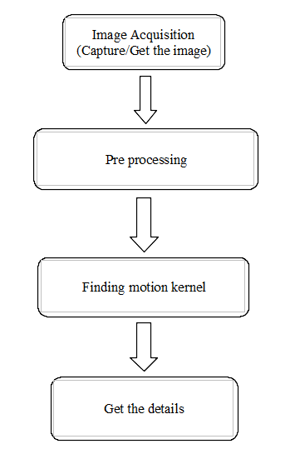

*Figure 1.1: Basic Approach*

**CHAPTER 2**

**LITERATURE REVIEW**

Vijayan Ellappan and Vishal Chopra published under number plate by IOP Publishing LtdIOP Conference Series: Materials Science and Engineering,Volume 263, Computation and Information Technology. Blur is a common in so many digital images. Blur can be caused by motion of the camera and scene object. In this work we proposed a new method for deblurring images. This work uses sparse representation to identify the blur kernel. By analyzing the image coordinates Using coarse and fine, we fetch the kernel based image coordinates and according to that observation we get the motion angle of the shaken or blurred image. Then we calculate the length of the motion kernel using radon transformation and Fourier for the length calculation of the image and we use Lucy Richardson algorithm which is also called NON-Blind (NBID) Algorithm for more clean and less noisy image output [2].

Qingbo Lu,Wengang Zhou,Chinese Academy of Sciences Key Laboratories, China: As the unique identification of a vehicle, license plate is a key clue to uncover over-speed vehicles or the ones involved in hit-and-run accidents. However, the snapshot of over-speed vehicle captured by surveillance camera is frequently blurred due to fast motion, which is even unrecognizable by human. Those observed plate images are usually in low resolution and suffer severe loss of edge information, which cast great challenge to existing blind deblurring methods. For license plate image blurring caused by fast motion, the blur kernel can be viewed as linear uniform convolution and parametrically modeled with angle and length. In this paper, we propose a novel scheme based on sparse representation to identify the blur kernel. By analyzing the sparse representation coefficients of the recovered image, we determine the angle of the kernel based on the observation that the recovered image has the most sparse representation when the kernel angle corresponds to the genuine motion angle. Then, we estimate the length of the motion kernel with Radon transform in Fourier domain. Our scheme can well handle large motion blur even when the license plate is unrecognizable by human. We evaluate our approach on real-world images and compare with several popular state-of-the-art blind image deblurring algorithms. Experimental results demonstrate the superiority of our proposed approach in terms of effectiveness and robustness [3].

Chittode J S et al. developed algorithm which is applied on the car park systems to monitorand manage parking services. Algorithm is developed on the basis of morphological operations and used for number plate recognition. Optical character is used for the recognition of characters in number plate.

Chunyu C et al. presented a technique for recognition of number plate from vehicle image. This technique is implemented using MATLAB and characters are recognized using edge detection segmentation and pre-processing of image.

Ganapathy V et al. developed a methodology for Malaysian vehicles. This methodology is mainly based on Hough transform and morphological analysis and results extraction of number plate with 95% accuracy [4].

**CHAPTER 3**

**METHODOLOGY**

The project implements with a method to get a clear image of motion blurred number plate images using previously captured images. Process of getting the final outcome is as follows.

**3.1 Image Acquisition**

Pre captured images are used to this project. For this, I have used images from the internet.

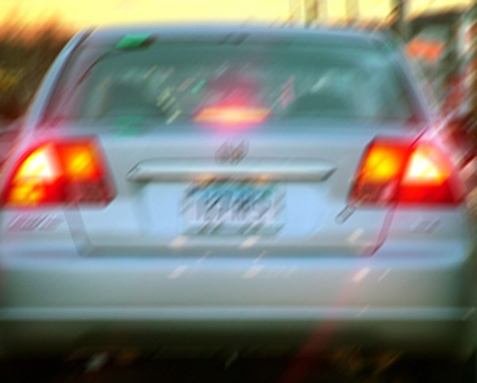

*Figure 3.1.1: Sample Image 1*

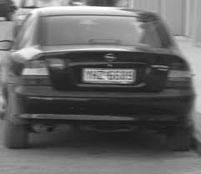

*Figure 3.1.2: Sample Image 2*

**3.2 Setting up the environment**

Import needed libraries to the program

* OpenCV
* NumPy
* Tkiner

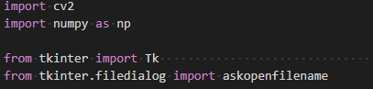

**3.3 Importing the image**

After importing the libraries, the image needed to be checked are loaded into the program. User needs to browse and open the image from the file open dialog.

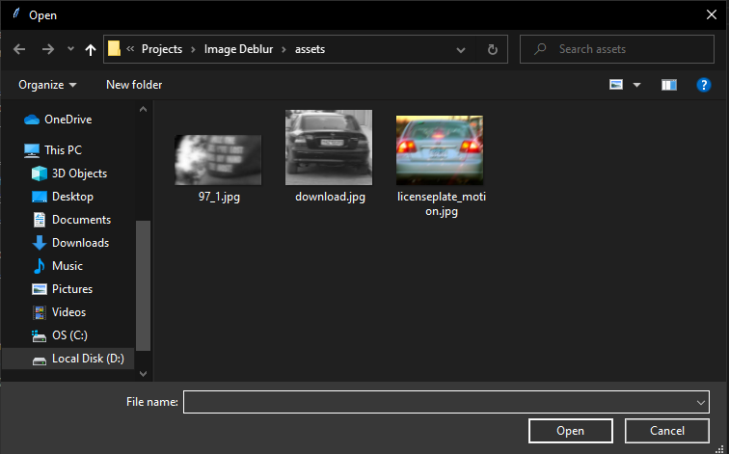

*Figure 3.3.1: File Browser*

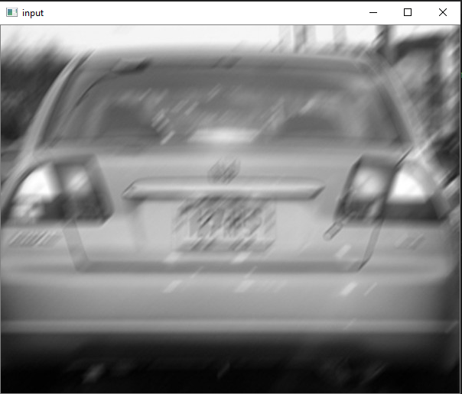

*Figure 3.3.2: Input Image*

**3.4 Preprocessing**

After importing image, image is treated with gaussian blur to remove noise and image is being converted into a 32-bit image (grayscale).

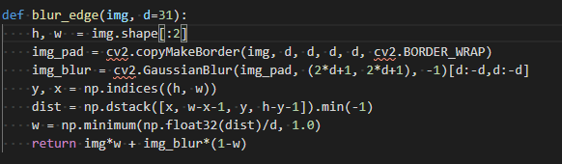

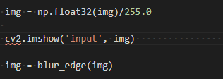

**3.5 Finding the motion kernel / point spread function**

After the preprocessing motion kernel / point spread function using fourier transformation techniques.



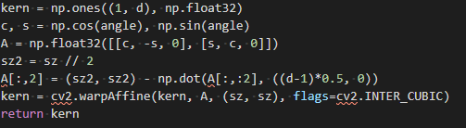

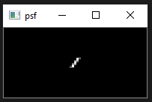

*Figure 3.5.1: Found PSF*

**3.6 Getting the details using the user interface**

After finding the PSF, user is prompted an user interface to adjust the length and the angle of the kernel to get the details.

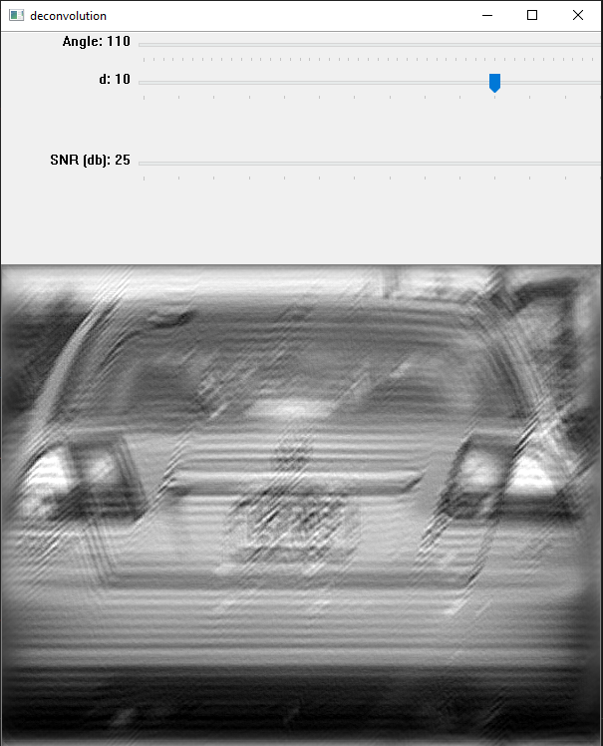

*Figure 3.6.1: User interface*

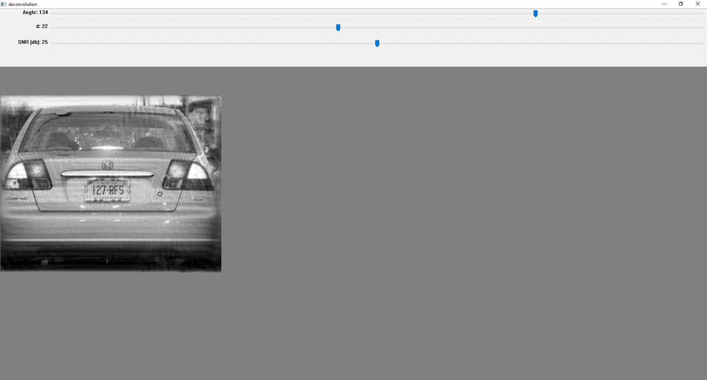

*Figure 3.6.2: Adjusted image*

**CHAPTER 4**

**RESULTS AND DISCUSSIONS**

Adjusting the length and the angle of the kernel manually leads to a better outcome because, user can adjust the kernel to the personally readable limit. Clearness of the final image depends on the kernel size as well as the resolution of the image. Images with lower resolution can be bit uncleared due to the operations.

Final result of above used image reveals the content on the number plate clearly.

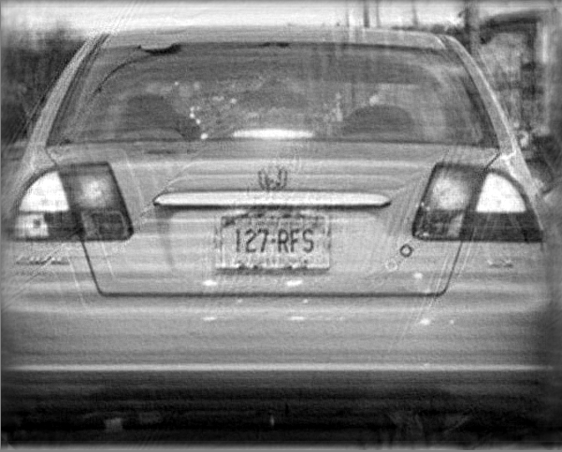

*Figure 4.1: Final output*

**CHAPTER 5**

**CONCLUTION**

The proposed system has tried to emerge with a parametric method to deblur the number plate image. The information lost due to blurring is restored by estimating a blur kernel. For this, fourier transformation techniques are used. Along with that the characteristics of motion blur are also taken into consideration while founding the blur kernel. After estimating the kernel, non-blind method is applied to get a deblurred number plate. The proposed system is able to restore the blur number plate image in human readable form.

**CHAPTER 6**

**FUTURE WORK**

Currently program cannot adjust the kernel size and length automatically, but I am hoping to develop the program to work automatically.

Also for now, program cannot extract the details of the image automatically. I am hoping to develop the program to detect the content automatically.

**REFERENCES**

1. Gonzalez C.Rafeal,Woods Richard E., ”Digital Image Processing”, London Pearson Education, 2002.
2. https://iopscience.iop.org/article/10.1088/1757-899X/263/4/042024/meta
3. <https://www.researchgate.net/publication/296480601_Robust_Blur_Kernel_Estimation_for_License_Plate_Images_From_Fast_Moving_Vehicles>
4. <https://www.researchgate.net/publication/266647262_Application_of_Image_Processing_to_the_Vehicle_License_Plate_Recognition>